NAKIDA ENTERPRISES LIMITED

Tunapanda • Tunapika • Tunasambaza
We Grow • We Cook • We Distribute
Agri-Business | Supplies | Catering
Reg. No: PVT-GYUQBGL6 | Established October 2014
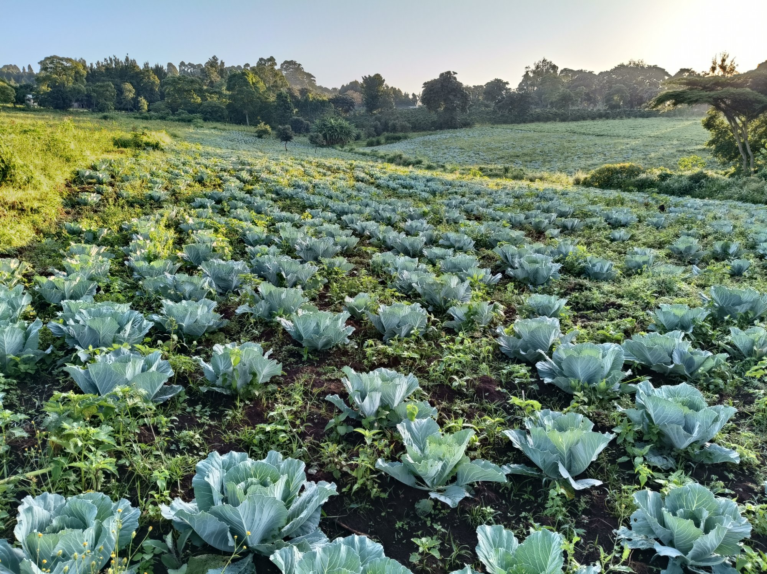
COMPANY PROFILE

About Us
Nakida Enterprises Limited is a Kenyan-owned multi-sector enterprise with a solid foundation built over more than a decade of service excellence. Founded in October 2014, the company began as a dynamic business entity committed to addressing critical needs in food supply. Driven by growth and a desire to better serve its clients, Nakida Enterprises transitioned into a fully registered limited company in August 2022, formally incorporated by the Registrar of Companies under the Companies Act 2014, under Registration Number PVT-GYUQBGL6. It has since grown from its initial supply-only mandate to include agriculture and catering.
From its earliest days, Nakida Enterprises has distinguished itself through a commitment to quality, reliability, and service diversity. The company operates across three core pillars — Agri-Business, Supplies, and Catering — enabling it to offer clients comprehensive, integrated solutions that span the full value chain from production to service delivery.
With experienced heads of departments overseeing each division, Nakida Enterprises ensures smooth coordination and operational efficiency across all its service lines, consistently delivering results that exceed client expectations.
Mission & Vision
OUR MISSION  To deliver quality agri-business, supply, and catering services with integrity and excellence. |  | OUR VISION  To be Kenya's most trusted enterprise in agri-business, food supply, and catering.
Our Core Values
Integrity  We uphold honesty and transparency in all our dealings. |  | Excellence  We strive for efficiency and quality in every service we deliver. |  | Accountability  We take responsibility for our actions and results. |  | Customer Focus  Our clients are at the heart of every decision we make.

Our Services
Nakida Enterprises Limited operates across three integrated service areas, allowing us to offer seamless, end-to-end solutions to our clients.
AGRI-BUSINESS  - Short-season crop farming  - Cabbage cultivation  - Bean production  - Potato farming  - Maize farming  - Goat rearing |  | SUPPLIES & CATERING  - Supply of food and dry goods  - Catering services for institutions  - Bulk food procurement  - Event and institutional catering

Our agri-business division focuses on short-season crops — including cabbages, beans, and potatoes — as well as maize farming and goat rearing. These activities support food security initiatives and provide fresh, reliable produce for our supply and catering operations. Our supply division handles procurement and distribution of food items and dry goods, while our catering arm delivers professional food services to institutions, government agencies, schools, and faith-based organisations.
Our Operations in Action
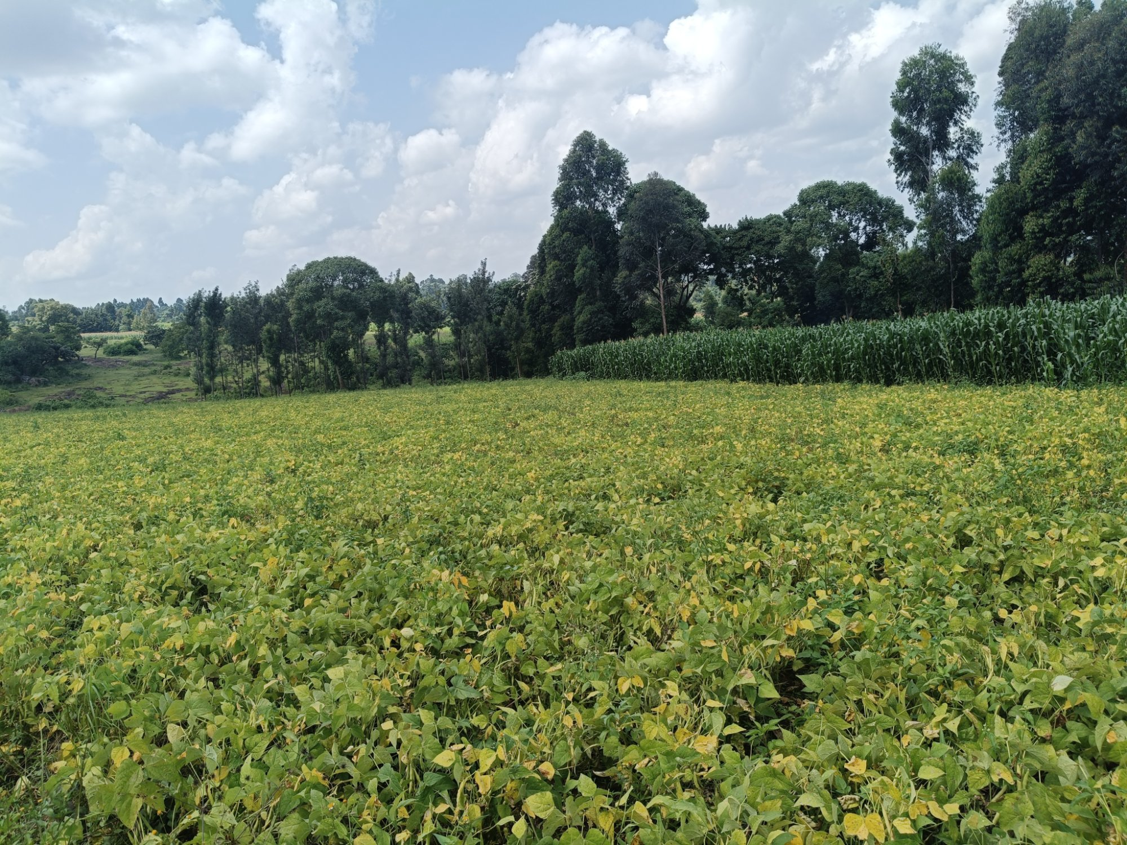 |  | 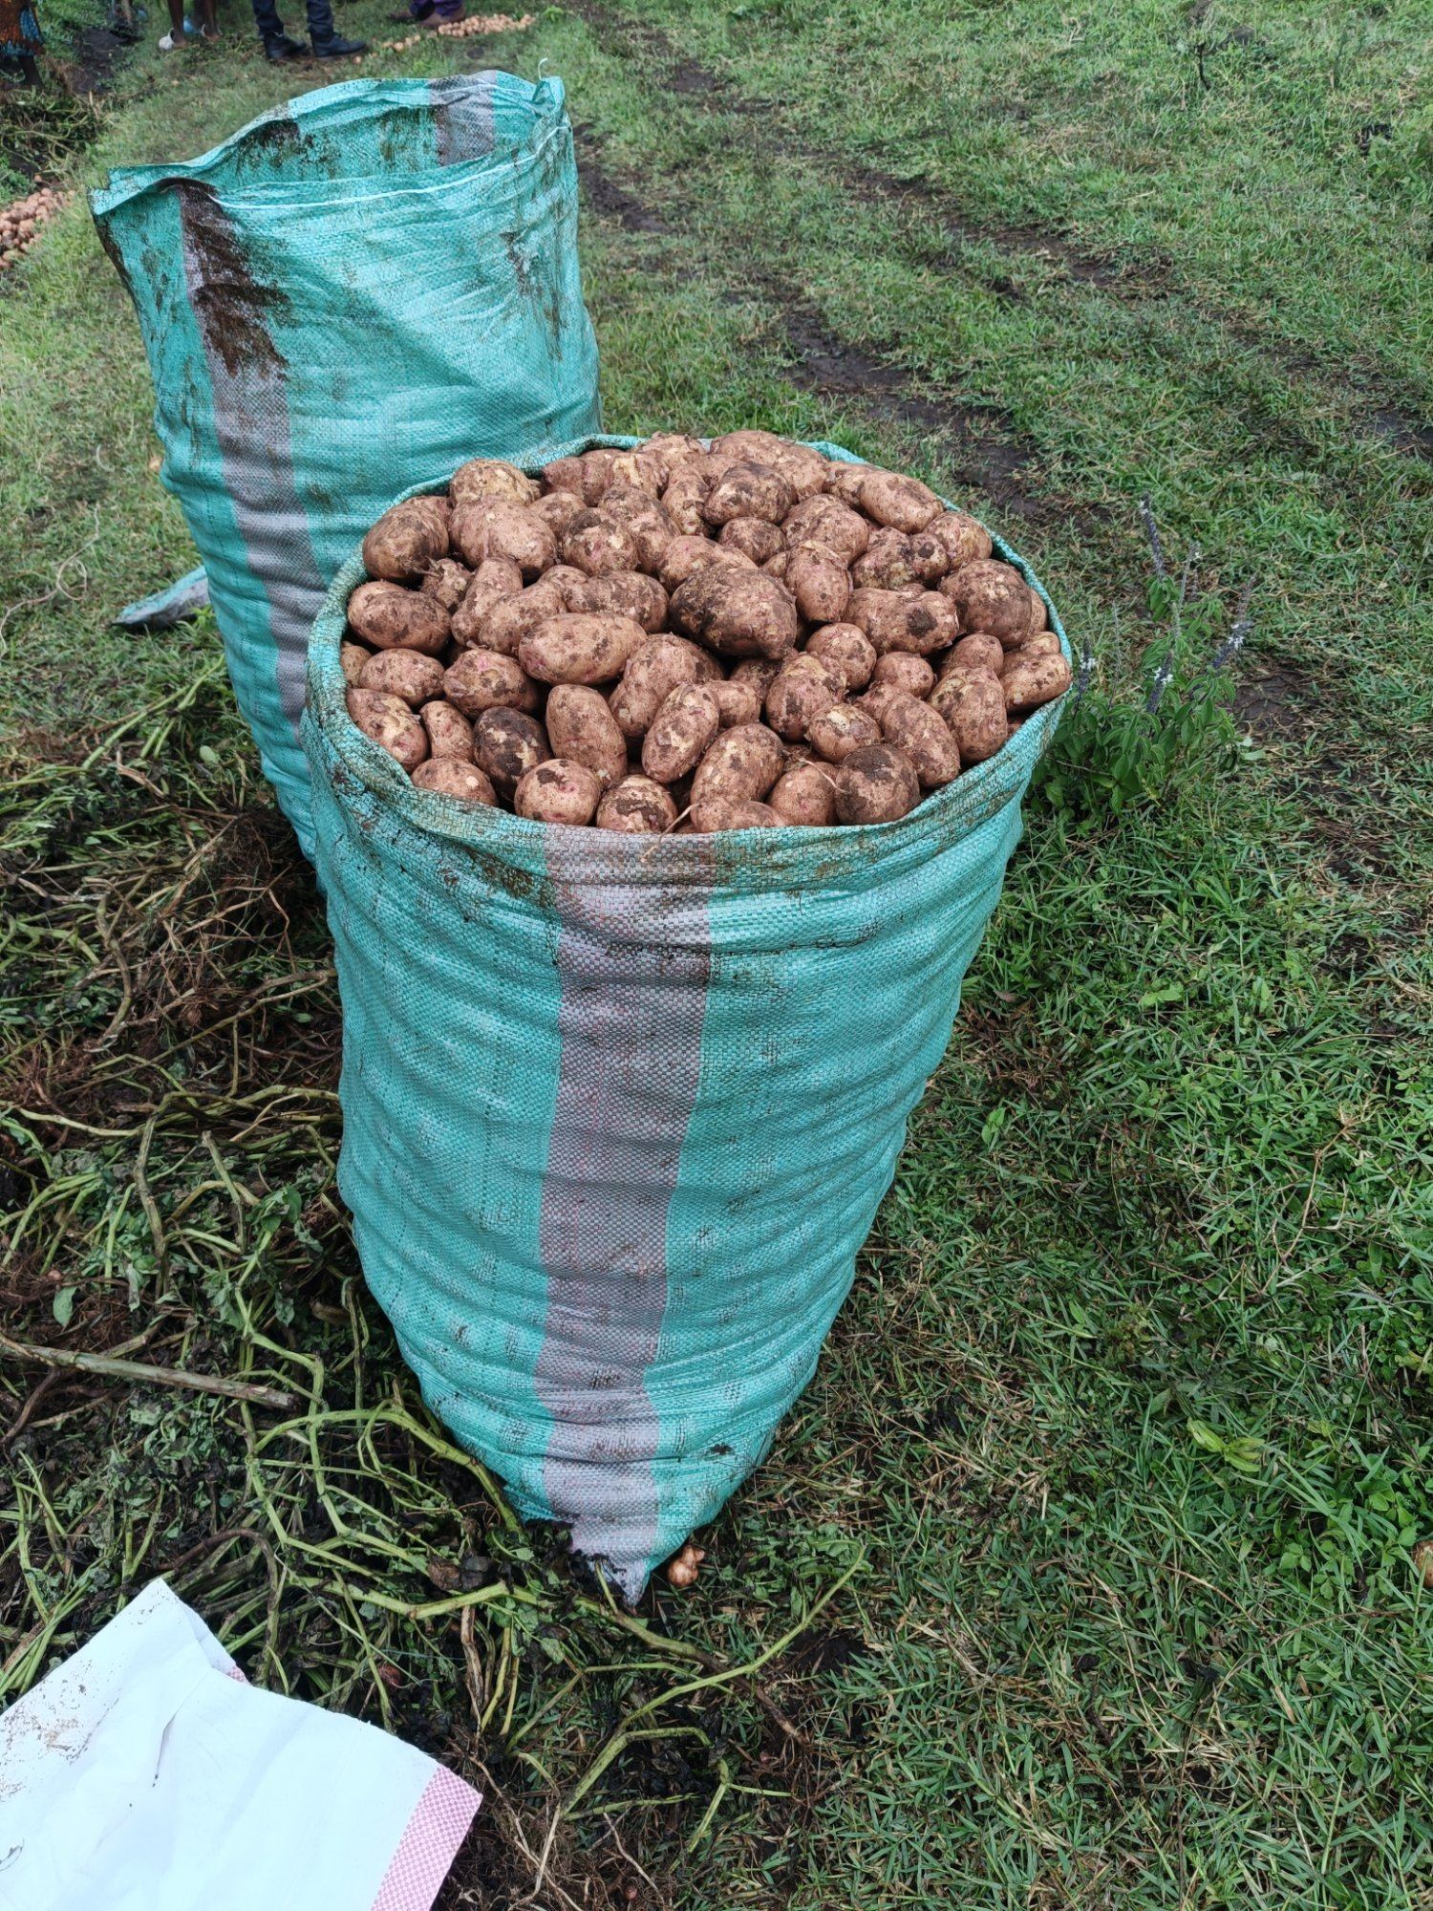
Bean production fields |  | Potato harvest ready for market

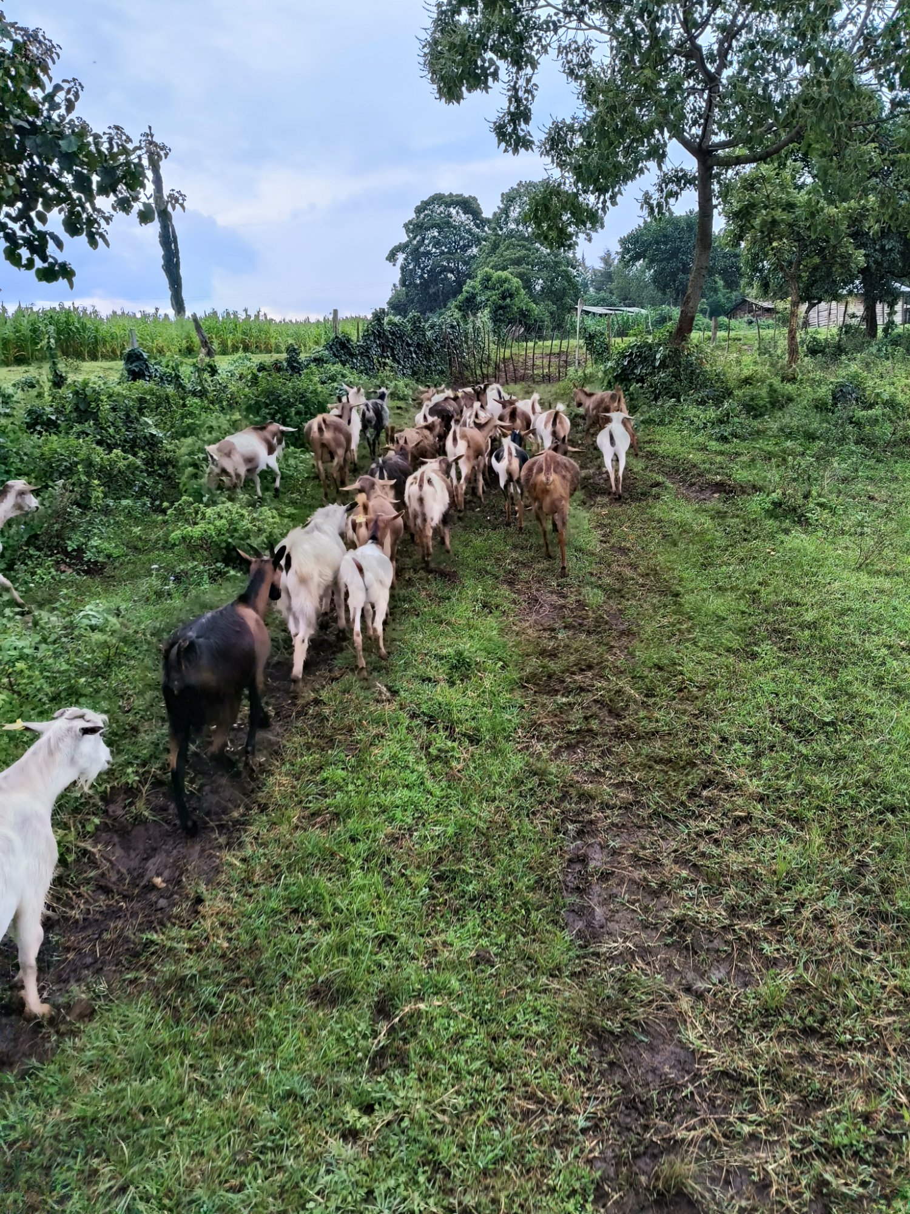 |  | 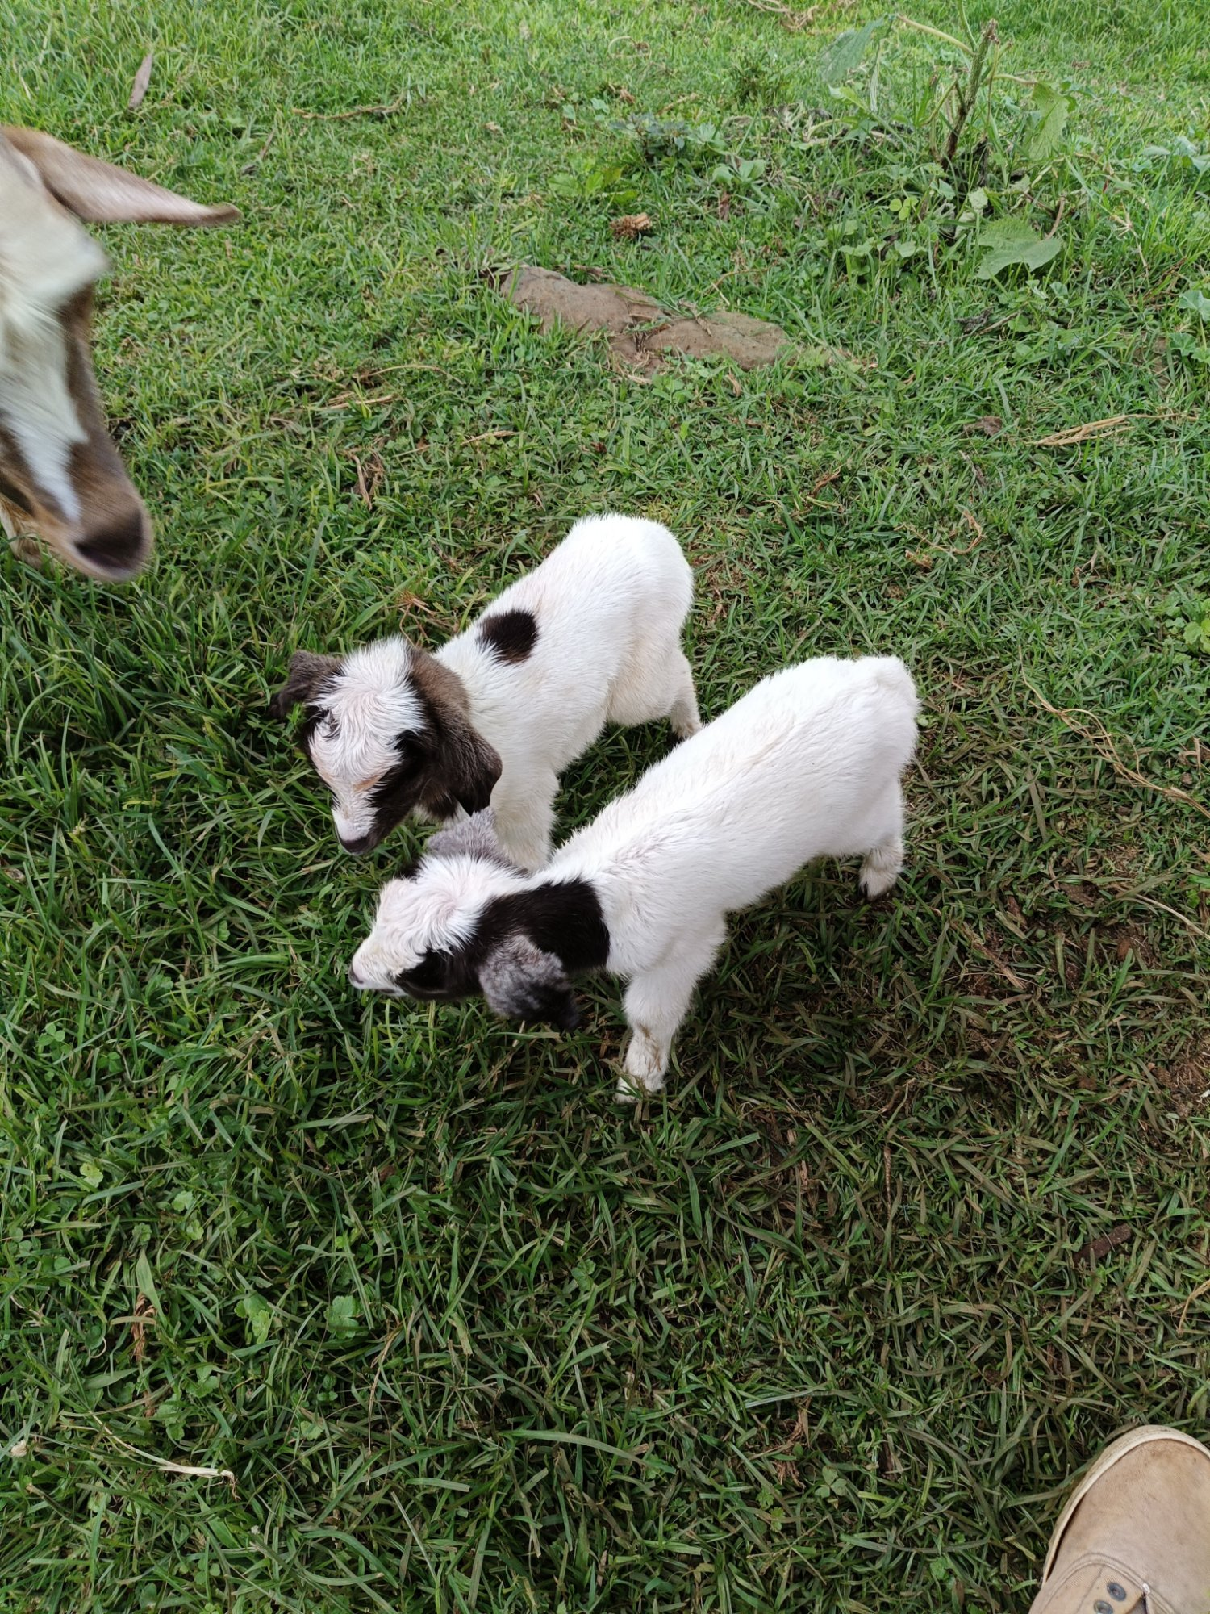
Goat rearing operations |  | Young kids from our livestock programme

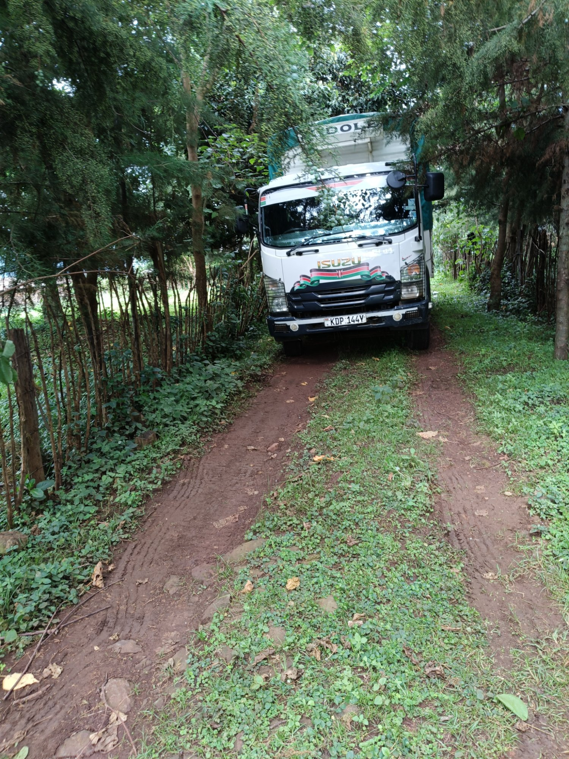
Our transport ensuring timely delivery

Why Choose Nakida Enterprises?
Partnering with Nakida Enterprises means choosing a company that understands the needs of its clients — and has consistently delivered for them over many years.
Proven Track Record  Over a decade of trusted service delivery across government, faith-based, and educational sectors. |  | Integrated Services  From farm to table — we produce, supply, and serve, offering a seamless end-to-end experience.
Quality Assurance  Strict standards at every stage ensure our produce and services consistently meet client expectations. |  | Reliable & Timely  We understand deadlines matter. Our experienced team ensures prompt and dependable delivery.
Diverse Expertise  Our experienced heads of department coordinate agri-business, logistics, and catering in harmony. |  | Kenyan Owned & Trusted  A proudly Kenyan enterprise registered under the Companies Act 2014, committed to the local economy.
Our Esteemed Clientele
We are honoured to have served and continue to serve a distinguished portfolio of clients across government, education, and the faith sector:
- Ministry of Agriculture — State Department of Livestock
- National Transport and Safety Authority (NTSA)
- Life Ministry
- International Christian Ministries
- Former Regis International School
- Riara Group of Schools
Our ability to serve such a diverse range of institutions — from government ministries to international schools — reflects the breadth of our competence and the depth of our commitment.
Get In Touch
We welcome enquiries from potential clients, partners, and stakeholders who share our vision of quality and reliability. Let us work together to deliver excellence.

NAKIDA ENTERPRISES LIMITED
info@nakida.africa
Telephone: +254 721 940 666
Tunapanda • Tunapika • Tunasambaza
We Grow • We Cook • We Distribute

